**[26] Design Turing Machine Simulation Which Accepts Palindrome String BBABB**

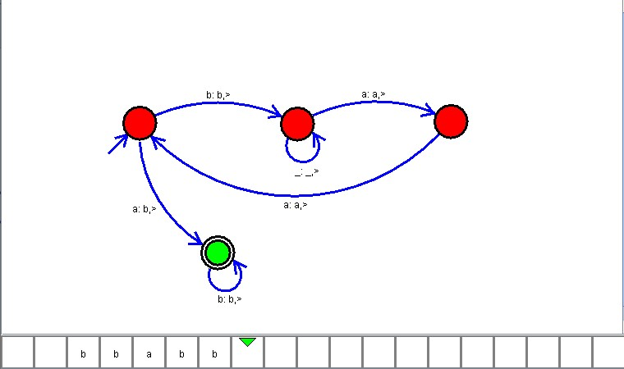

**Result**

The TM is designed to compute the given palindrome strings as input using Simulator